KEC BOOK RESOURCES

SOUL CARE

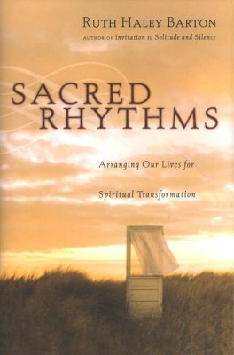
Sacred Rhythms: Arranging Our Lives for Spiritual Transformation
by Ruth Haley Barton

In response to our heart’s desire for intimacy with God, Barton guides us on a journey through monastic traditions (rule of life) to a useful understanding of seven spiritual disciplines. Useful because she helps us “get” how they might fit in our lives. Each chapter includes exercises to help us begin the practices, individually and as groups. The final chapter puts it all together in a way that helps us arrange our lives for spiritual transformation.

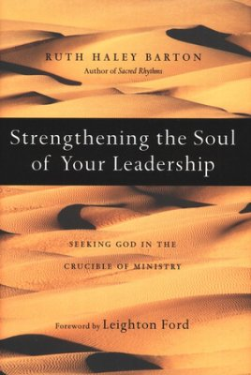
Strengthening the Soul of Your Leadership: Seeking God in the Crucible of Ministry
by Ruth Haley Barton

Barton helps us consider the danger of ignoring the health of our souls as we lead. It is possible to do good things while destroying ourselves or even our churches. She helps us identify the danger areas, teaches us the art of paying attention to our souls and guides us toward healthy rhythms in ministry. A good resource for the leader, Barton’s book becomes even more valuable when read by leadership teams. Strengthening the soul of your leadership conversations create a network of relationships that will serve each member and your church for years to come.

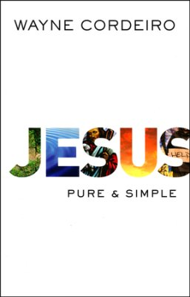
Jesus: Pure & Simple
by Wayne Cordeiro

Cordeiro offers an invitation to reconsider our days, days that can be busy and complicated, wearing us down. Unfortunately, this can spill over into our service to the King. This book reminds me that our walk with Jesus should be just that, “pure and simple.”

Soul Detox: Clean Living in a Contaminated World
by Craig Groeschel

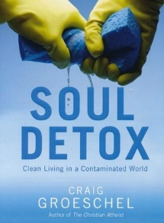
We hardly notice as we walk through daily life that our souls are becoming stained. Groeschel explains that every day we’re infected with spiritual toxins from our corrupt culture. What are we to do? How can we purify ourselves from poisonous influences, emotions, and behaviors? Groeschel encourages us to embrace the radical new life Jesus calls us to, as he shines the light of truth on moral ambiguity we must grapple with daily. Holiness could become our new reality.

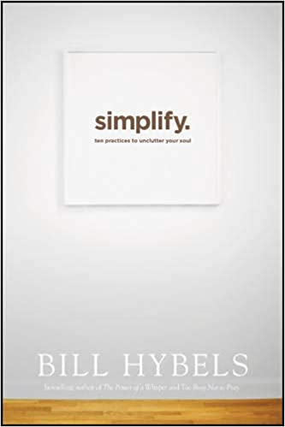
Simplify: Ten Practices to Unclutter Your Soul
by Bill Hybels

Busy. Really busy. Our badge of honor becomes our undoing. As soon as we accept this pace as normal, we begin to we sacrifice the things that matter. Hybels addresses the question, what if your life could be different? And then helps us unpack the uncluttering of our souls. We do so by setting aside the stuff that leaves our spirits drained and doing what does matter. Hybels’ offers practical steps for decluttering our souls.
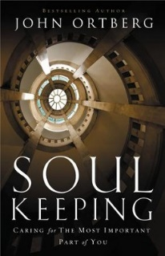
Soul Keeping: Caring for the Most Important Part of You
by John Ortberg

Ortberg highlights one of the more “overlooked, underrated, and misunderstood” parts of our lives. That we have lost touch with our source our life leaves us prone to anxiety, depression, fear, and loneliness. He offers a reasonable approach to living the "with God" life. The fruit? Lasting peace and satisfaction.

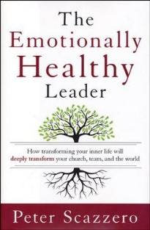
The Emotionally Healthy Leader: How Transforming Your Inner Life

by Peter Scazzero

Skill set? Isn’t that what makes for great leader? Scazzero suggests that the effective leader blends who she is with what she does. At the intersection of our inner lives and the doing of ministry, Scazzero helps us explores our "shadow," marriage or singleness, relationship with Jesus, and Sabbath delight, in search of how “self” impacts our planning, decision making, team building, and so much more.

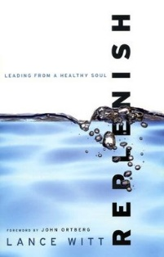
Replenish: Leading from a Healthy Soul

by Lance Witt

Leaders function on two stages - the front stage or public world, and the backstage or private world. Though leaders are often measured by what they do on the front stage, it’s our attention to the backstage for effective ministry. Witt encourages us as he shows us how to prioritize matters of the soul, develop healthy spiritual practices, address problems that lead to burnout, and how to lead an unhurried life. Witt offers a welcome relief and healthy way forward.

PASTOR, PLANTER & LEADERSHIP DEVELOPMENT

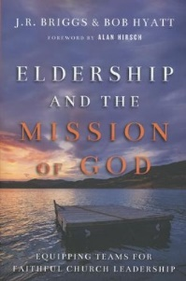
Eldership and the Mission of God: Equipping Teams for Faithful Church Leadership
by J. R. Briggs

The biblical model for church leadership is found in teams of elders who together guide the community into God's mission. Briggs and Hyatt provide a comprehensive picture of elders as agents of mission for their communities. Looking at eldership through a missiological lens, Briggs and Hyatt unpack the role, character, and posture of a mission-oriented elder. Elders oversee, shepherd, teach, equip, and model for God's people what life with Jesus looks like in a particular context. The book includes a study guide so teams can work through together.

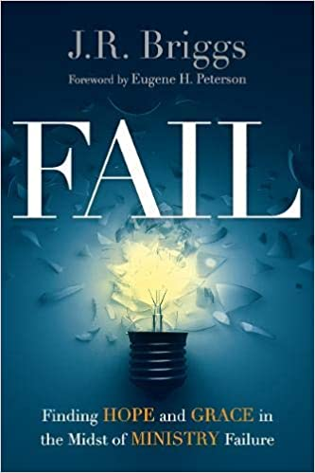
Fail: Finding Hope and Grace in the Midst of Ministry Failure
by J. R. Briggs

What do we do after we've failed? Some ministries are shipwrecked by moral failures like affairs or embezzlement. But for most of us, the sense of failure is more ordinary: disillusionment, inadequacy, declining budgets, poor decisions, opposition, depression, burnout. Many pastors are deeply broken and wounded, come to doubt that God has any use for them. Briggs knows what failure feels like. He challenges our cultural expectations of success and gives us permission to grieve our losses. He offers the hope of the grace of healing and restoration.

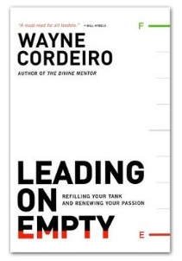
Leading on Empty: Refilling Your Tank and Renewing Your Passion
by Wayne Cordeiro

Do you feel fried? No more zip? Maybe you are under the weight of your leadership responsibilities. Running for a while in this situation, are you now running on fumes? Cordero challenges us to not let burnout get the best of us. From his own experience, Cordeiro shows us how to keep our tanks from running dry. Developing balance, getting our life back, allows God to re-energize us.

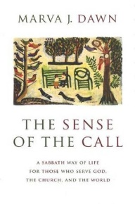
The Sense of the Call
by Marva J. Dawn

Marva Dawn issues both a timely challenge and a ceaseless invitation to participate in the life of the church. For in that place of service we will find joy and fulfillment. She warns that America has become like the late Roman empire, a place where poverty and immense wealth stand side by side and compassion is drowned by entertainment. Let Dawn's call for social justice and compassion move you to action.

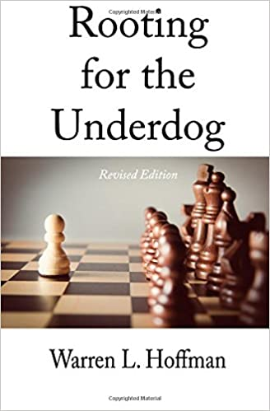
Rooting for the Underdog
by Warren L. Hoffman

Hoffman has collected stories that thrill the soul of the pastor, church leader or ministry team who thinks they have run out of ideas. These stories are success (???) stories of men and women and congregations who have pressed beyond “we can’t” or “we don’t have enough.” What did they find? Jesus. New life. These underdogs found hope and press on the measurable successes. Tread! be encouraged.
Newly Revised! Rooting for the Underdog is a collection of essays written by Warren L. Hoffman over his years of supporting "underdog" churches: faltering, disadvantaged, under-resourced, out-of-the-way, or simply ordinary churches. In Rooting for the Underdog, Warren brings God’s message of hope and encouragement, along with practical advice gleaned from his over 45 years of ministry experience, to those working in and with those underdog churches.

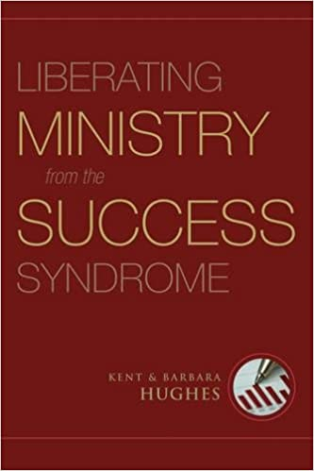
Liberating Ministry from the Success Syndrome
by Kent and Barbara Hughes

Every year thousands of God's servants leave the ministry convinced they are failures. Years ago, in the midst of a crisis of faith, Kent Hughes almost became one of them. But instead he and his wife Barbara turned to God's Word, determined to learn what God had to say about success and to evaluate their ministry from a biblical point of view.
This book describes their journey and their liberation from the "success syndrome"-the misguided belief that success in ministry means increased numbers. In today's world it is easy to be seduced by the secular thinking that places a number on everything. But the authors teach that true success in ministry lies not in numbers but in several key areas: faithfulness, serving, loving, believing, prayer, holiness, and a Christlike attitude. Their thoughts will encourage readers who grapple with feelings of failure and lead them to a deeper, fuller understanding of success in Christian ministry.

The Heart of a Great Pastor
by H. B. London & Neil Wiseman

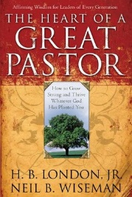
London and Wiseman appreciate pastors and the lives they get to live. Their intent is to encourage, inspire and support them. They explain that they need to help them count the cost of serving Christ; they need to equip themselves by learning from those who have gone before them. They offer advice . . . get a mentor? Verify your calling. Make sure your family are on the same page? Live in the Word for yourself first. And so much more.

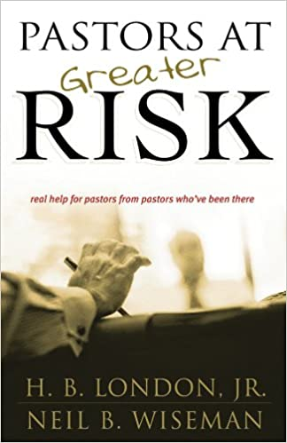
Pastors at Greater Risk
by H. B. London & Neil Wiseman

Some of today's pastors are relatively untroubled but need help in releasing the pressure inherent in ministry to others. Others are close to running on empty, both spiritually and emotionally. All of them would like someone to confide in who can provide realistic help based on firsthand experience. This is precisely what "Pastors at Greater Risk" is all about! First published in 1993, this edition is completely rewritten, with updated stats, interviews with contemporary pastoral leaders and a special emphasis on today's hot-button issues- job turnover, pornography, spiritual burnout, congregational turnover and more! Result: A book that is rich in wisdom and understanding and one that provides pastor-to-pastor help at a time when it is needed more than ever!

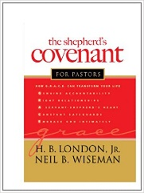
The Shepherd’s Covenant
by H. B. London & Neil Wiseman

Like having a serious conversation with a mentor or coach in the ministry, "The Shepherd's Covenant for Pastors" offers the equipping that pastors need to maintain their commitment to live their lives and ministries with authenticity and integrity. Readers will covenant with God and with one another to maintain a life of holiness and righteousness by committing to five basic principles built on an acrostic of G.R.A.C.E. This inspiring book includes input on the importance of maintaining and developing each principle, stories of pastors who have experienced positive and growing ministries by applying the principles and a series of exercises for keeping in spiritual shape.

RETHINKING HOW WE THINK
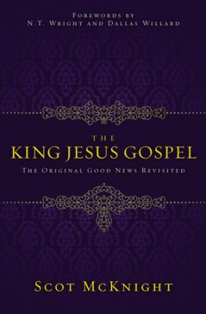
The King Jesus Gospel
by Scot McKnight

McKnight offers an excellent rethinking and refocusing of the Gospel. McKnight helps us process what the Bible says about the Gospel so we can go forth with the Gospel of Jesus.

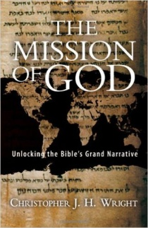
The Mission of God: Unlocking the Bible’s Grand Narrative
by Christopher Wright

Wright’s book is for those interested in what the “missional” shift is all about and is a biblically faithful, thorough, and compelling explanation of the mission of God in the world. Wright makes it clear that as God’s people we are expected to continue in that mission not simply as one thing among others but as the fundamental purpose of the church in the world.

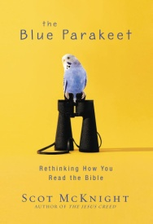
The Blue Parakeet: Rethinking How You Read the Bible

by Scot McKnight

McKnight takes us on a serious journey into and out of our approach to Bible reading and study. Do we merely assume “what was then” should be for now? Do we pick and choose the nuggets we want to consider? Do we have a system (besides “it works for me”) regarding the application of “old” commands? McKnight challenges us to read the Bible as it was written – it’s a story, an unfolding drama of God and Creation (including and especially man). If it’s a story, then the end rests upon the rest of the story. There is no pick and choosing of nuggets. There is no static Law. Everything must be applied in the context of the reading. “What was then” may be true, but what should it look like today?

ENGAGING OTHERS

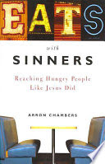
Eats with Sinners: Reaching Hungry People Like Jesus Did
by Arron Chambers

“…go and make disciples….” Simple? Right? Then why do we struggle so to share the gospel with our neighbors? Chambers speaks into this dilemma by noting that Jesus ate with real people. Why? There is power in the act of eating together. Perhaps we might consider following Jesus’ example as we deepen relationships, share the gospel, and watch the Spirit do what he does best. Change lives. And yes, Chambers provides recipes.

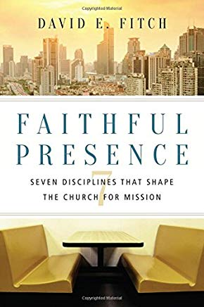
Faithful Presence: Seven Disciplines that Shape the Church for Mission
by David Fitch

David Fitch helps us remember that we live in a post Christian world. Our new friend might be a generation or more away from a church connection. We need to plan to be effective witnesses, not throw in the towel. Fitch guides us to think presence, to live in the moment with our neighbor. He also challenges us to be a community restored to God's presence in Jesus Christ and faithfully present to him in the world. Fitch calls for a recovery of seven disciplines that have been with us since the birth of the church. Read. Be stretched.

Dinner Church: Building Bridges by Breaking Bread

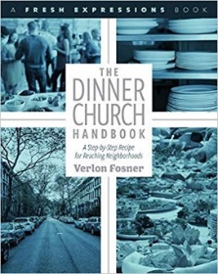
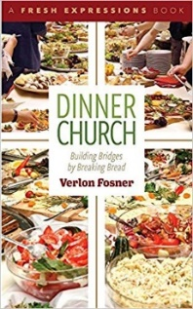
and

The Dinner Church Handbook

by Verlon Fosner

What are we to do when we recognize communities unlikely to walk into a church? Feed them! Fosner explains that people love to gather over and around food. Dinner Church weaves church into and around a meal. Dinner Church takes church to the unchurched, to those who might not walk into a church building.

Surprise the World! The Five Habits of Highly Missional People

by Michael Frost

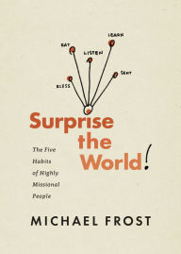
Frost offers a story and a few simple ideas on how to engage people so that we earn permission to tell them about the Kingdom of God. What he offers are a few attitudes or intentions that radically change our daily lives. Frost calls his approach the BELLS model (Bless others, eat together, Listen to the Spirit, Learn Christ, and understand yourself as Sent by God into others’ lives). Just think, we can eat with people as a tool for developing and deepening relationships! What if we did that with people who don’t know Jesus?

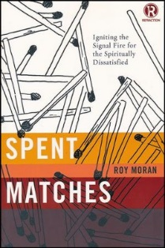
Spent Matches: Igniting the Signal Fire for the Spiritually Distressed
by Ray Moran

Spent Matches explores the possibility that a few small paradigm shifts within the church might make the difference between extinction and effectiveness. In fact, taking a clue from the automobile industry, the church might be able to not only halt the rapid decay in attendance but also become an effective tool in achieving Jesus' final command. For instance, the Hybrid car has become the answer to Detroit's environmental and oil crisis issues. Finding the synergy between two technologies, gas and electric has created a new day for the auto industry. Likewise, Spent Matches explores how the church can find synergy between two seemingly competing thoughts: an invitation to come and a command to go. The Hybrid metaphor brings energy to the church's mission and an explanation to the age-old argument of Missional versus Attractional methods.

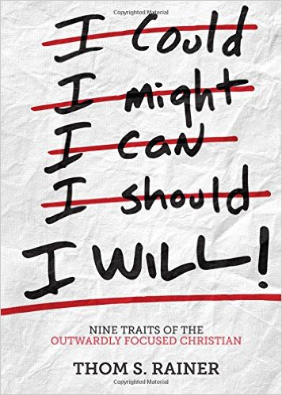
I Will: Nine Traits of the Outwardly Focused Christian
by Thom S. Rainer

Rainer challenges us to do more than think about ourselves and our own church. If we are indeed in love with Jesus (the Jesus of the Bible) and His Church (not our church), then we will think of others (and their needs which we might be able to address). Maybe we can learn to think of others first, especially since we naturally think of ourselves.

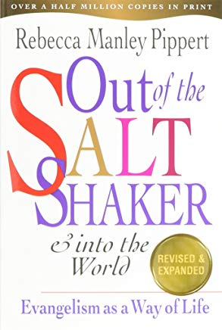
Out of the Saltshaker & Into the World: Evangelism as a Way of Life

by Rebecca Manley Pippert

This is NOT a new book. It’s a classic, speaking into our lives as witnesses. Yes, we are often uptight about evangelism. Manley Pippert clears away some of the fog of what to do. Clear explanations and stories walk us out of the fog. Enjoy this easy read as you glean numerous helpful ideas.

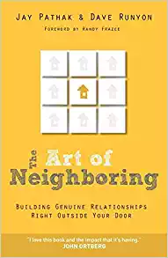
The Art of Neighboring: Building Genuine Relationships Right Outside Your Door
by Pathak & Runyan

Pathak and Runyan remind us we used to KNOW our neighbors. But sadly, today, we “might” only know their names. Maybe. You see, we live radically different lives. Fast paced. Disconnected. Filled with superficial relationships. The authors paint a portrait of a lifestyle that weaves together prayer, learning names and developing significant relationships with our neighbors. The hold forth that doing so might lead to witness.

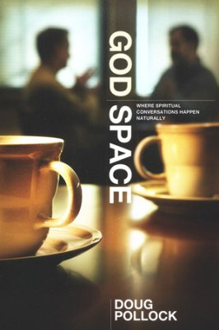
God Space: Where Spiritual Conversations Happen Naturally

by Doug Pollock

Pollock uses stories to help us imagine the bridges we might make use of to place the gospel before the lost people in our lives. An everyday conversation can become a moment of witness. That brief moment at work or play, across the backyard fence, could be a moment of witness.

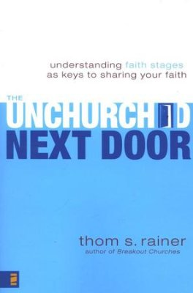
The Unchurched Next Door
by Thom Rainer

Do you KNOW your neighbor? Rainer challenges us to not just think about them but to learn them. Think about what they think about. Rainer provides stages of responsiveness and how to work with people in each stage. Explanations and insights become resources to the evangelist. Rainer acknowledges that there is no ONE way to reach the unsaved.

The New Parish: How Neighborhood Churches Are Transforming Mission, Discipleship and Community
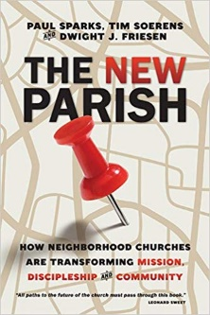
by Paul Sparks, Tim Soerens, and Dwight J. Friesen

What if faith communities came together? What if this larger community loved their neighborhood? What if the gospel became visible and tangible? The authors suggest a parish mentality – working together for a community might be a solution for changing the face of a community, meeting the needs of a community, and fleshing out the gospel in ways that make Jesus more real, more attractive. And the gospel more compelling.

